Ex.no:9 | MINI PROJECT – FINANCE ANALYTICS

Domain and Problem Regionment
Domain: Financial Data Analytics & Financial Performance Analysis

Problem Regionment:
Financial organizations generate large volumes of transaction-related data but often lack clear insights into revenue, expenses, profit, customer spending, and regional patterns. This project addresses these challenges by transforming financial data into structured business intelligence using Power BI and Tableau, enabling analysis of transaction distribution across regions and cities, revenue trends, profit patterns, expense behavior, and overall financial performance to support data-driven financial analysis.

Dataset Description
Dataset Name: Financial Analytics Dataset Granularity: Each row represents a single financial transaction. Key Entities & Attributes:
- Transaction & Customer: transaction_transaction_id, Customer, Account, Category
- Financial Information: Amount, Revenue, Profit, Expenses
- Financial Performance: ROI, Payment Method

Data Source:
Primary Source: Financial Analytics Dataset prepared for financial transaction and performance analysis.

Storage Infrastructure:
Cleaned and pre-processed financial transaction records maintained in a CSV dataset and imported into Microsoft SQL Server, Power BI and Tableau for interactive dashboard development and analysis.

Architecture:
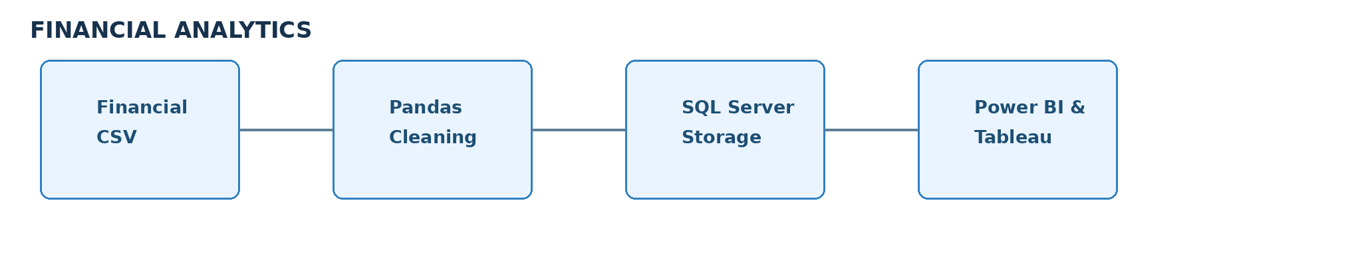

Program:
- Python – Data Cleaning & Transformation
import pandas as pd
df = pd.read_csv("Financials In India (Anonymized).csv") financials = df.copy()

transactions["Category"] = transactions["Category"].fillna("Unknown") transactions["Region"] = transactions["Region"].fillna("Unknown") transactions["Payment_Method"] = transactions["Payment_Method"].fillna("Unknown") numeric_columns = [
"Amount", "Revenue", "Profit", "Expenses",
"ROI"
]
for column in numeric_columns: transactions[column] = transactions[column].fillna(0)
transactions.drop_duplicates(inplace=True) transactions.columns = (
financials.columns
.str.lower()
.str.strip()
.str.replace(" ", "_")) print("Original Shape:", df.shape)
print("\nDataset Preview:") print(transactions.head())
print("\nDataset Information:") print(transactions.info())

- SQL SERVER CONNECTIVITY

INSTALL SQL SERVER MANAGEMENT STUDIO
- Create database named “financialDB”
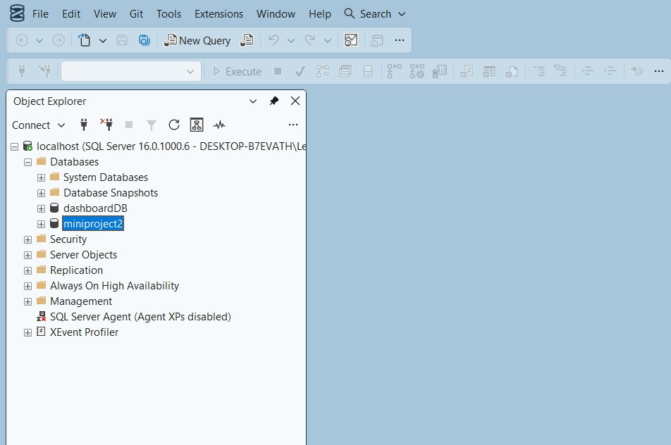
- Import the csv file of the financial dataset
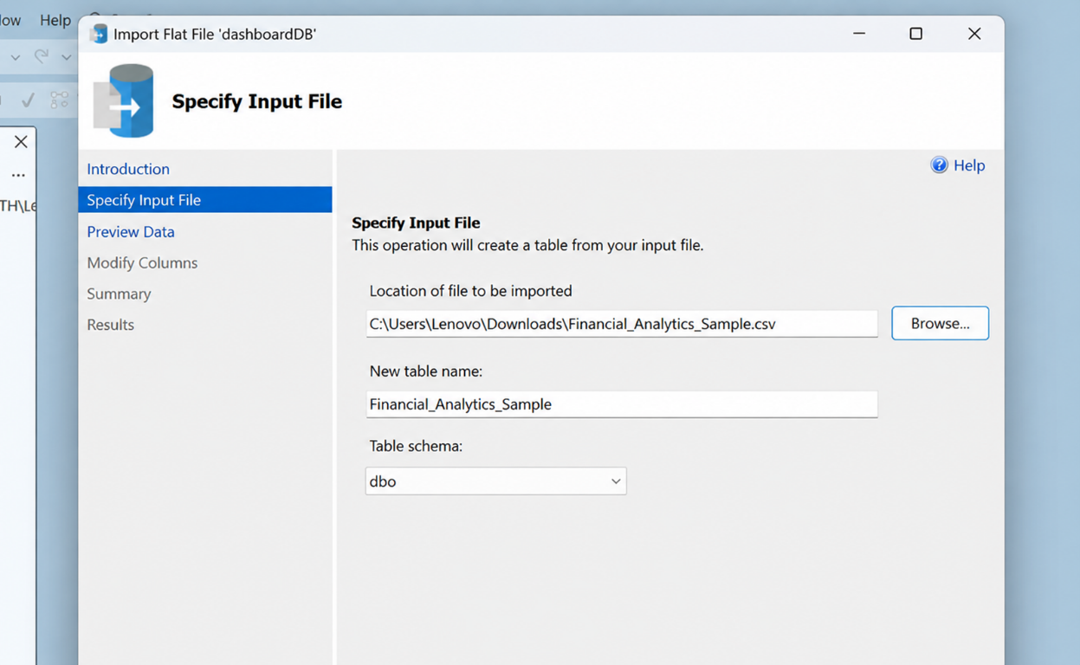

POWER BI
- Now go to MICROSOFT POWER BI
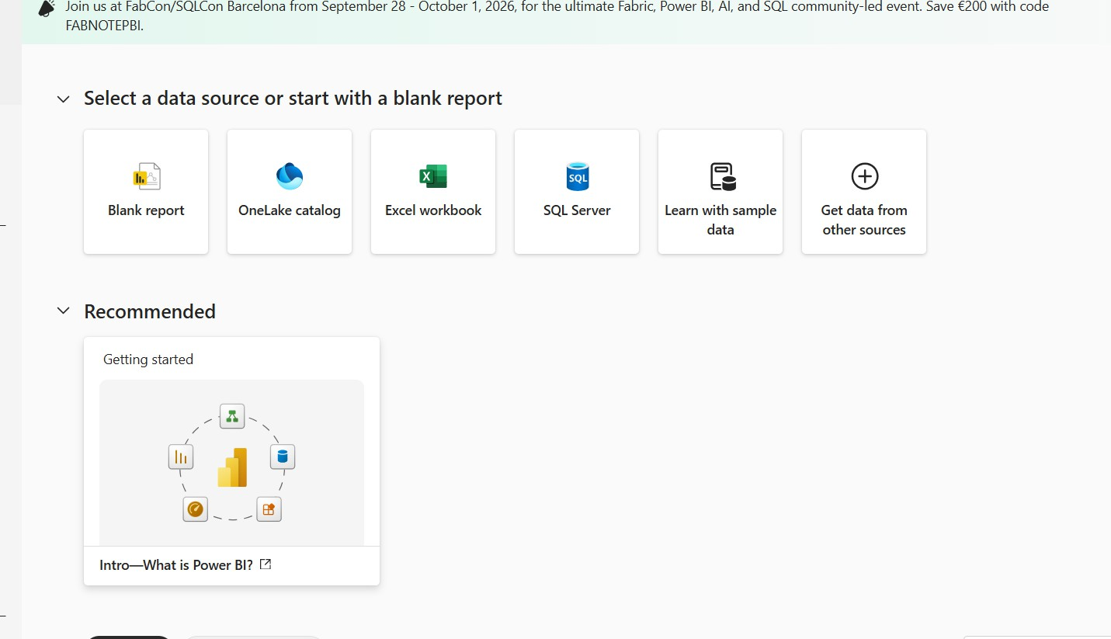

- Click SQL SERVER
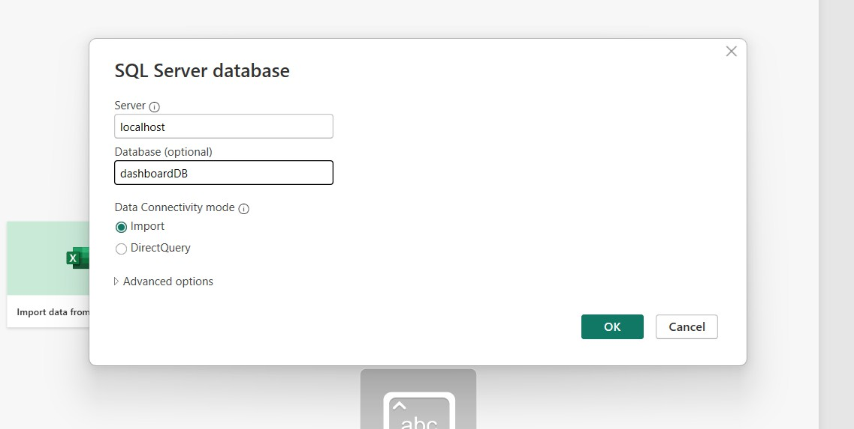

- Click OK and click transform data
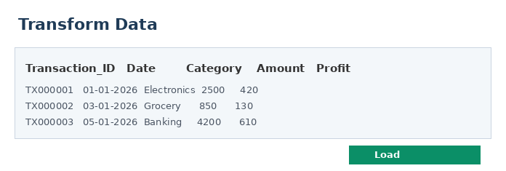

- Create DAX measures TOTAL TRANSACTIONS :
AVERAGE PROFIT :
- Power BI Final Financial Dashboard & Drill-Through
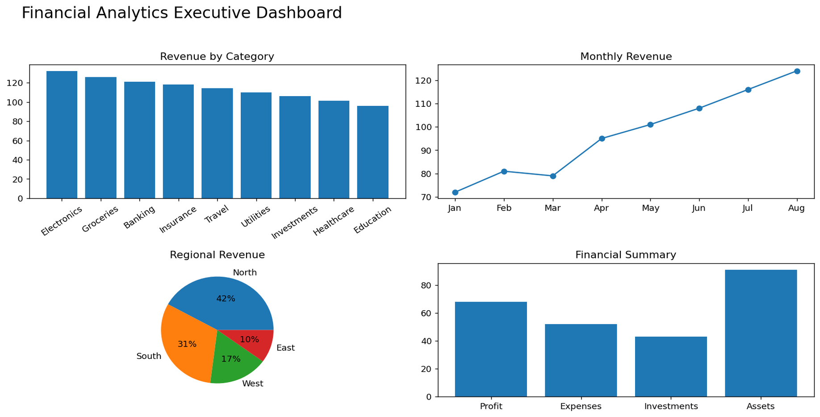

1. Executive Canvas:
Place Card Visuals across the top:
Visualise total revenue in each region
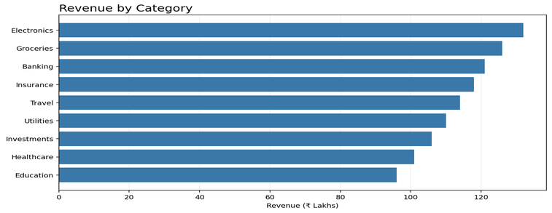

count number of transactions by city
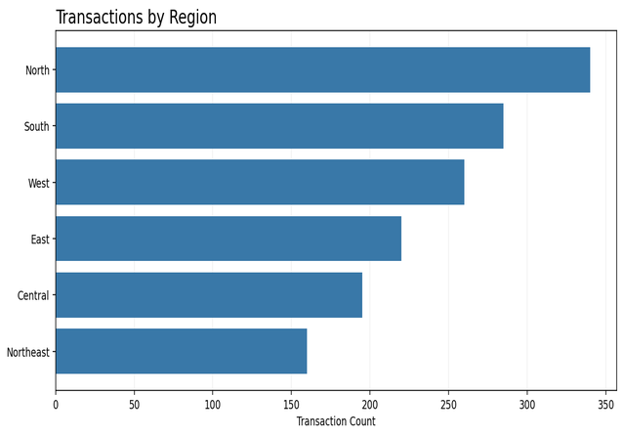

Count of transaction_id by profit
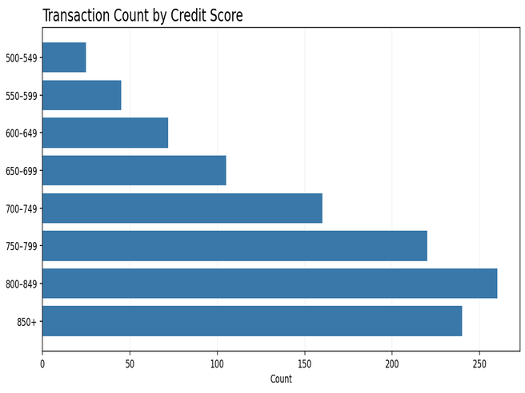
Total profit by regions
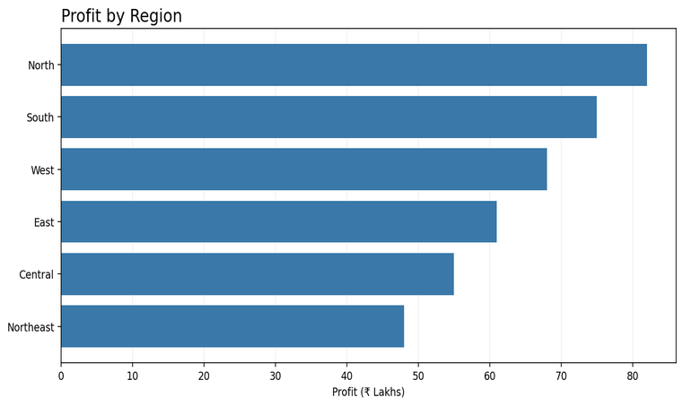

Create 2 slicers by region and city
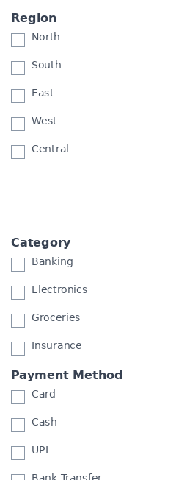

Implement drill through
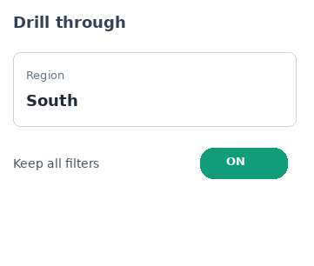

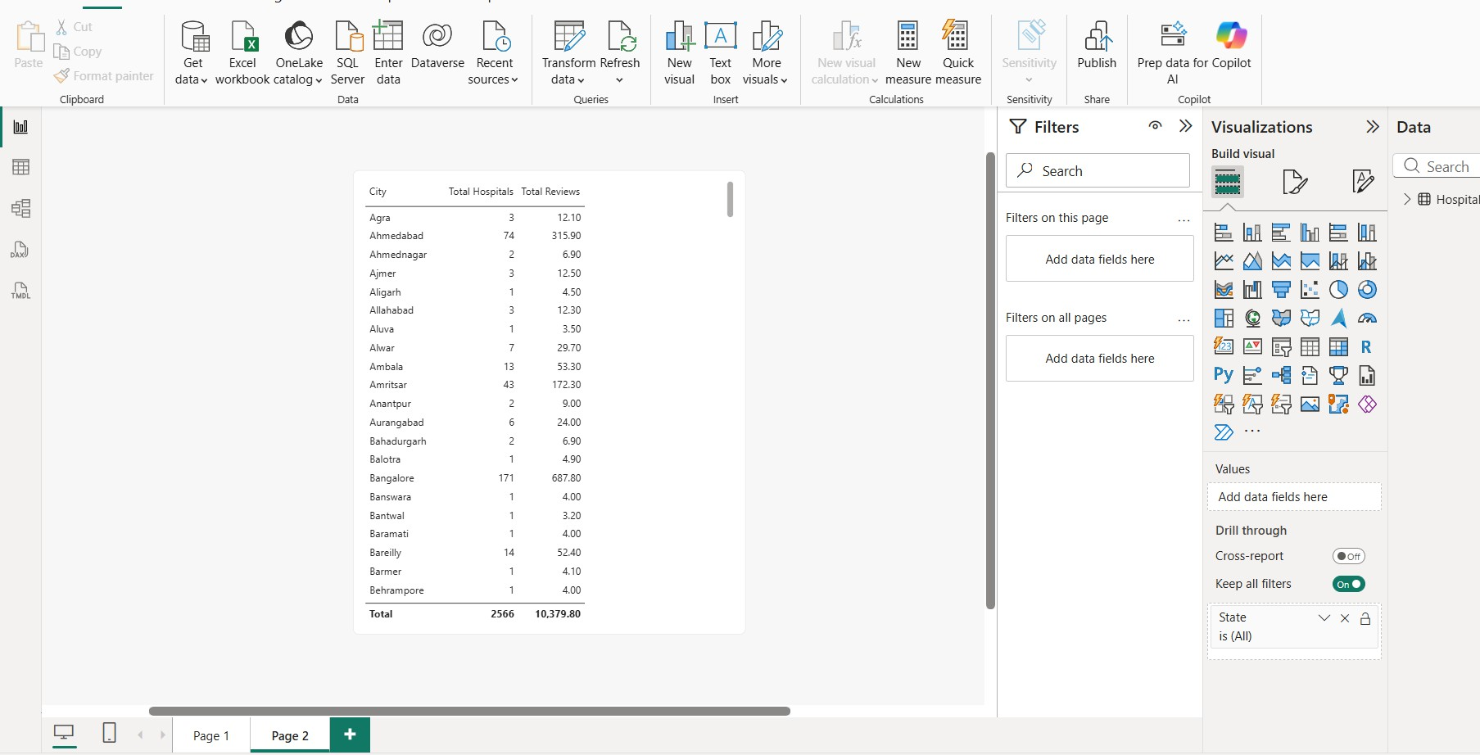

TABLEAU
Import the financial data from sql server
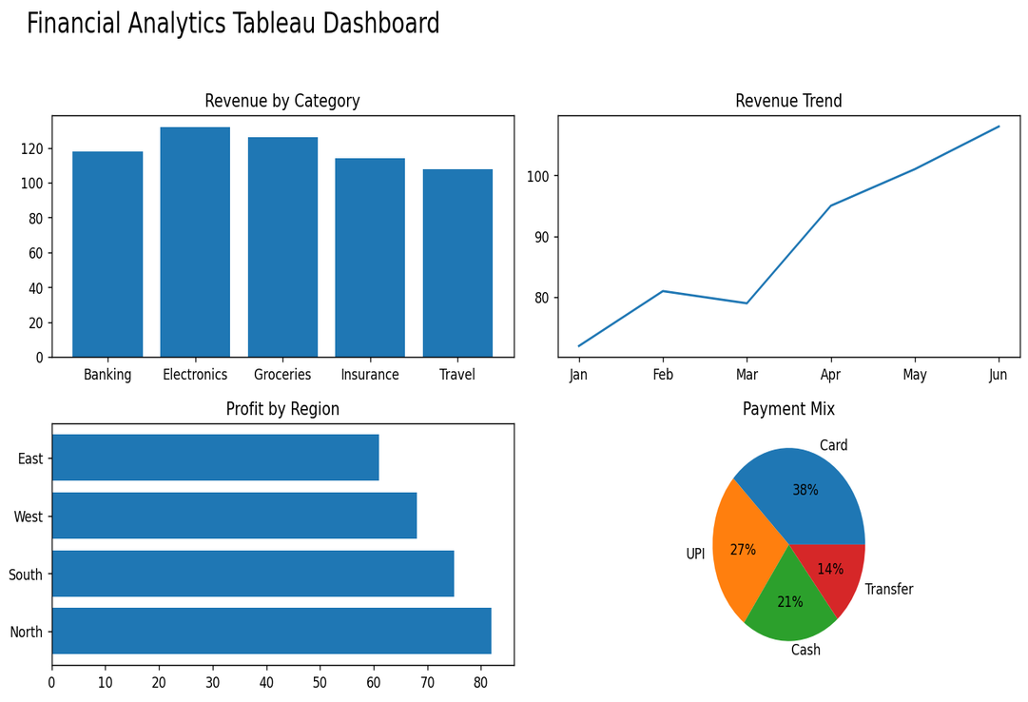

FINAL FINANCIAL DASHBOARD :
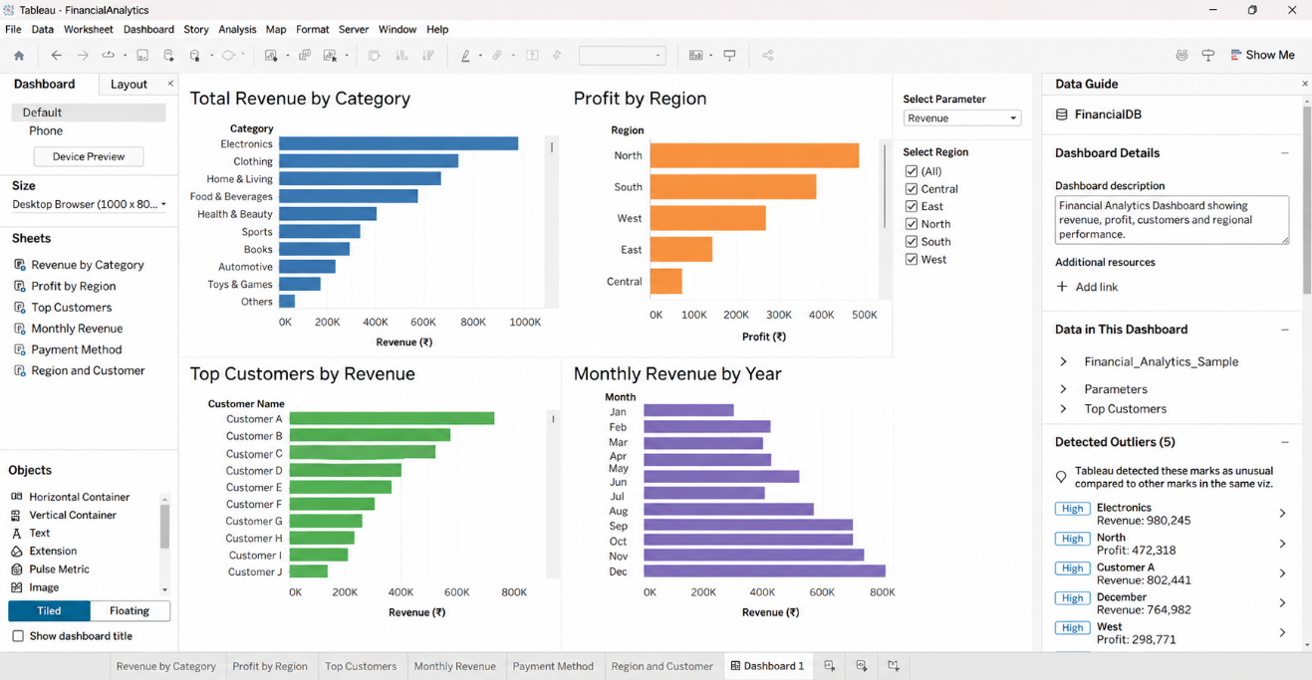

Build parameters
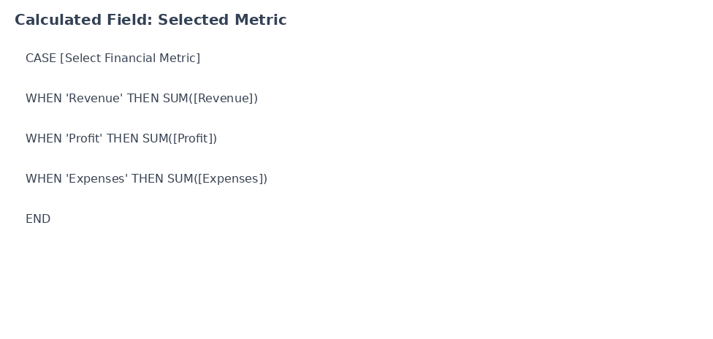

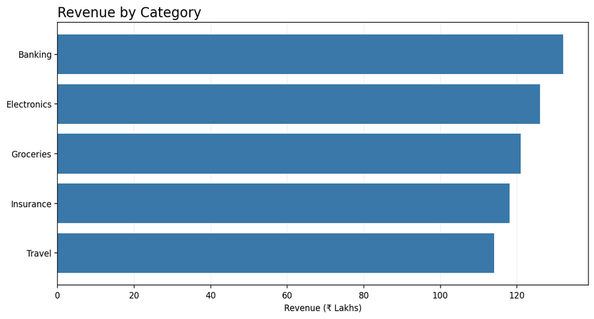

To visualise transactions by profit
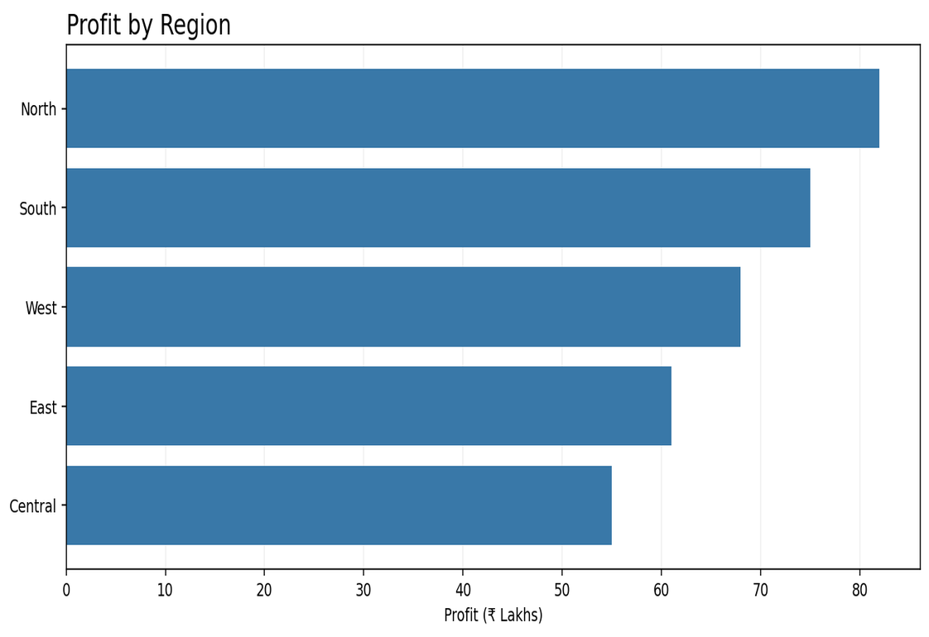

To visualize profit by state
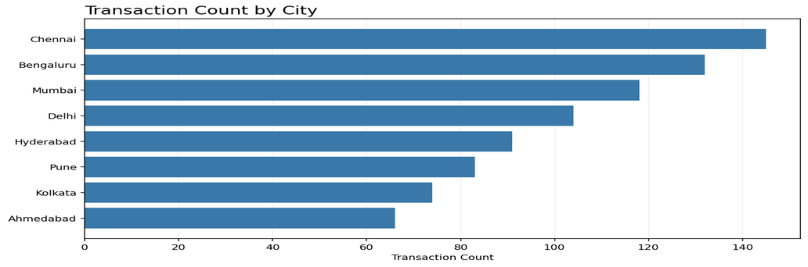

To visualize number of financials in each city
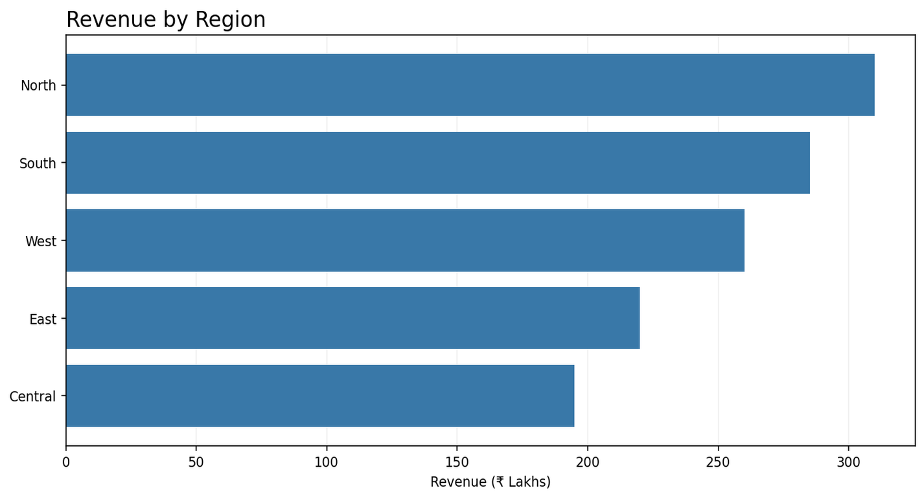

To visualise number of financials in each state
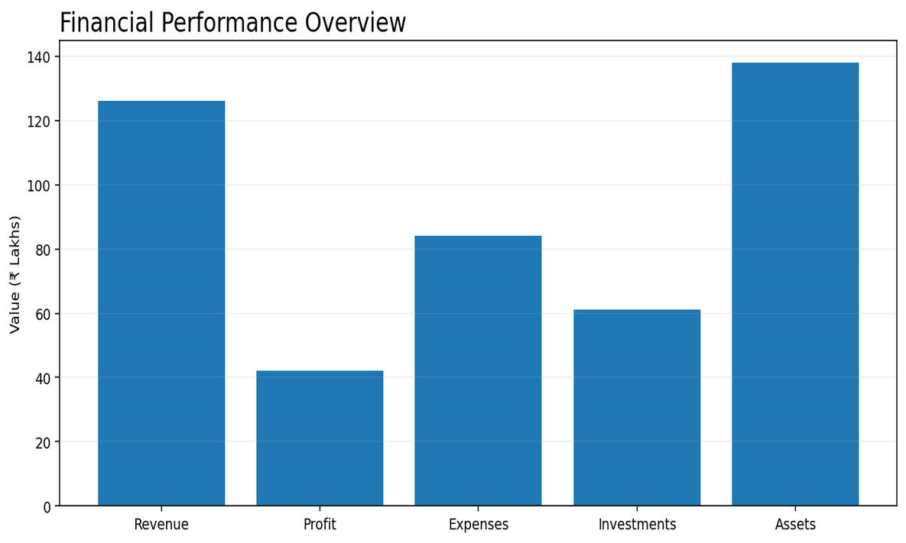

Observed Insights

- Financial Performance
The financial dashboard shows variation in transaction amounts and profitability across the dataset. Higher-value transactions contribute substantially to total revenue, while profit levels vary across indivtransaction_idual transactions. The overall financial indicators provtransaction_ide a clear view of revenue generation and profitability.
- Profit by Region
The dashboard shows differences in profit-related values across the regions displayed. North and South contribute significant profit values, while other regions show comparatively lower totals. Regional comparison helps transaction_identify areas with stronger financial performance.
- Transaction Distribution by City
The dashboard shows that transaction volumes vary across cities. Major cities such as Chennai, Bengaluru, Mumbai, Delhi, and Hyderabad contribute noticeable transaction counts, while several other cities have comparatively fewer transactions.
- Revenue Distribution by Region
Revenue varies across the regions represented in the financial dataset. The North and South regions contribute substantial revenue values, while the remaining regions contribute smaller portions. This regional view supports comparison of financial activity across locations.

